
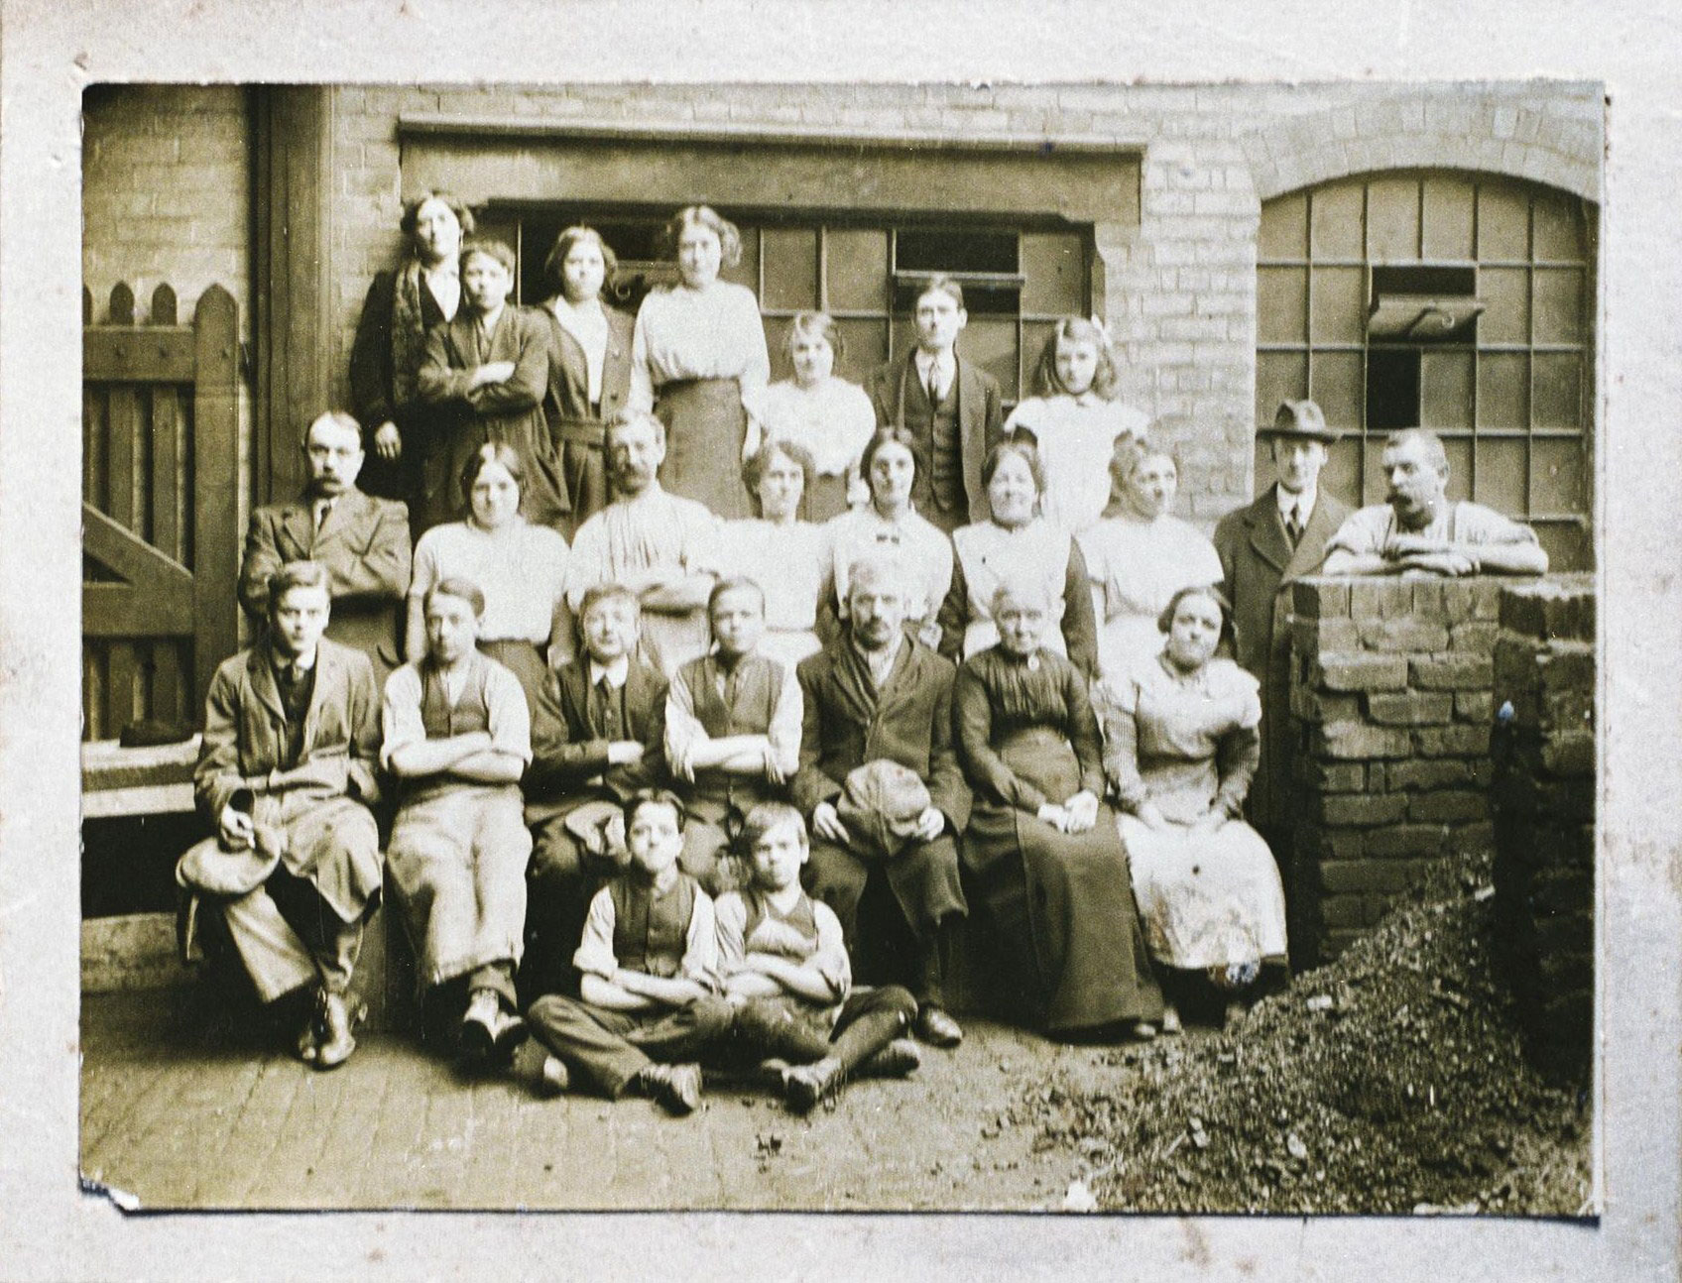
Study sources A - C
Source A

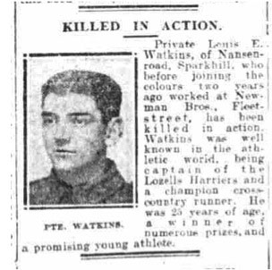
Source B
Lewis was born in 1892 in Sparkhill, Birmingham. By the age of 19, in 1911 he was a ‘Brass Polisher’ working at Newman Brothers. His dad, Edward, was also employed at a coffin furniture works, presumably also Newman Brothers. Although the identification is not certain, Lewis may appear in a photograph of the Newman Brothers workforce taken about 1912, in the front row at the extreme left (see Source B)
On 20th October 1915, with the First World War well underway, Lewis answered the call to enlist and joined the Royal Garrison Artillery (RGA). He had just turned 23 years old. His service records tell us that Gunner Lewis Watkins progressed to ‘millwright’, which involved the maintenance of machinery. This is a skill he is likely to have already developed through his work at Newman Brothers.
Lewis died on 26th September 1917, aged 25.
Source C
Vacancies Advertised in the Birmingham Mail by Newman Bros. Fleet Street, Birmingham 1914-1918 (edited)
*See conditions at head of column.
DEFENCE OF THE REALM ACT - Advertisements in the situations vacant columns from Firms whose business consists wholly or mainly in engineering, shipbuilding, or the production of arms, ammunition or explosives, or of substances required for the production thereof, are, in order to comply with Regulation 8 (b) of the above Act, subject to the following conditions:- "No person resident more than 10 miles away or already engaged on Government work will be engaged."

Date | Advertisement
08/01/1914 | POLISHERS- Girls wanted, used to Emery Bobbing and Finishing - Newman Bros., Fleet St.
21/01/1914 | GIRL Wanted, about 18 years, used to the press - Newman Bros., Fleet St.
26/01/1914 | POLISHERS- Girls wanted, used to finishing Brass work - Newman Bros., Fleet St.
26/03/1914 | GIRL Wanted, about 16 years, used to brassfounders' warehouse - Newman Bros., Fleet St.
05/03/1914 | GIRL Wanted, about 16 for Wiring in plating shop - Newman Bros., Fleet St.
09/05/1914 | BRASS-CASTING- Getter Down and Core Maker Wanted at once. Full Time - Newman Bros., Fleet St.
09/05/1914 | LACQUERING- Girl Wanted, about 15 - Newman Bros., Fleet St.
18/07/1914 | COFFIN Furniture- Blacker Wanted, thoroughly used to the trade - Newman Bros., Fleet St.
23/06/1914 | BRASSFOUNDRY. Youths Wanted, used to the file and float; also Lads - Newman Bros., Fleet St.
24/06/1914 | MOULDER Wanted, used to cabinet brassfoundry - Newman Bros., Fleet St.
12/09/1914 | YOUTH Wanted, used to file and float; also boys to learn - Newman Bros., Fleet St.
10/11/1914 | POLISHERS- Female, used to finishing - Newman Bros., Fleet St.
19/01/1915 | GIRLS (Young) Wanted for scratchbrushing and wiring up in plating shop - Newman Bros., Fleet St.
23/01/1915 | STAMPERS Wanted, used to coffin furniture preferred - Newman Bros., Fleet St.
19/02/1915 | GIRLS Wanted, used to the Shroud trade; also Learners - Newman Bros., Fleet St.
17/03/1915 | GIRL Wanted (strong), used to scratchbrushing, iron work - Newman Bros., Fleet St.
19/03/1915 | STAMPERS Wanted, used to coffin furniture preferred - Newman Bros., Fleet St.
17/06/1915 | LADS Wanted- to learn the brass trade - Newman Bros., Fleet St.
26/06/1915 | POLISHERS- Girls wanted, used to Emery Bobbing and Finishing; no person resident more than 10 miles away or already engaged on Government work will be engaged. Newman Bros., Fleet St.
08/07/1915 | BRASSFOUNDRY- Stampers Wanted, Men and Youths - Newman Bros., Fleet St.
17/07/1915 | POLISHERS- Girls and Youths Wanted for emery bobbing and finishing - Newman Bros., Fleet St.
22/10/1915 | POLISHERS- Girls wanted, used to Emery Bobbing and Finishing; also Young Girls to learn - Newman Bros., Fleet St.
22/10/1915 | POLISHERS- Men and Women Wanted at once. *See conditions at head of column - Newman Bros., Fleet St.
23/10/1915 | STAMPERS Wanted, used to coffin furniture. *See conditions at head of column - Newman Bros., Fleet St.
19/01/1916 | GIRLS (age about 16 years) Wanted for warehouse - Newman Bros., Fleet St.
25/01/1916 | BRASSFOUNDRY- Man Wanted; one used to dressing coffin handles preferred; to take charge of shop: permanent situation - Newman Bros., Fleet St.
21/03/1916 | SCRATCHBRUSHERS- Girls Wanted, about 17 or 18 - Newman Bros., Fleet St.
24/05/1916 | GIRLS Wanted for the shroud trade - Newman Bros., Fleet St.
24/05/1916 | WAREHOUSEMAN and Packer Wanted; one used to the Brassfoundry trade preferred - Newman Bros., Fleet St.
28/02/1917 | LACQUERERS, Girls Wanted. *See conditions head of Col. Newman Bros., Fleet St.
19/04/1917 | BRASSFOUNDRY- Lads and Elderly Men Wanted, used to turning. See conditions head of column. Newman Bros., Fleet St.
05/05/1917 | MAN, (elderly) Wanted, to assist in Brasfounders' Rough Warehouse and Packing Room. *See conditions head of column. Newman Bros., Fleet St.
05/05/1917 | BRASSDRESSERS- Men Wanted over 61, permanent situations. Also Lads to learn. *See conditions head of column. Newman Bros., Fleet St.
07/05/1917 | POLISHERS- Girls Wanted, used to Emery bobbing and Finishing, brass work - Newman Bros., Fleet St.
05/07/1917 | STAMPERS- Youths or Men over 61, used to coffin furniture preferred - Newman Bros., Fleet St.
16/07/1917 | SCRATCHBRUSHING- Girls Wanted, about 15 - Newman Bros., Fleet St.
18/08/1917 | MAN Wanted, over 61, for packing and rough warehouse - Newman Bros., Fleet St.
11/06/1918 | NICKEL-PLATING and Brassing, Girls Wanted for scratchbrushing etc.., - Newman Bros., Fleet St.
25/09/1918 | LADS Wanted, used to the stamp. *See conditions head of column. Newman Bros., Fleet St.
Questions
- Which of these sources is more useful for an historian exploring the proportion of women working at Newman Brothers in the early 20th Century?

- Describe two types of job that young girls were recruited to do in the factory during the war years.

- Explain why vacancy adverts often indicated the age of the girls they wanted to hire? Why would a younger female workforce be good for business?

- How significant was The Military Service Act ruling in January 1916 and how did this effect recruitment strategies at the factory for women and men?

- Gender equality in the workplace did not exist in the early 20th Century. How far do you agree with this statement using the sources and your knowledge to explain your answer.

